Phillip Jauregui

Project 2 Design Doc

User Stories:

* Manage Product
  + Common Use Cases
    - User Loads a Product
      * User loads a product
      * Product loads successfully without conflict
    - User Saves a Product
      * User edits a product/creates a new one
      * User saves product
      * Product saves successfully without conflict
  + Exception
    - User loads a product
      * User loads a product
      * Product fields conflict with type of fields or fields don’t exist
      * Product doesn’t load successfully
    - User saves a product
      * User edits a product/creates a new one
      * Product fields conflict with type of fields or existing fields in other products
      * Product doesn’t save successfully
* Manage Customer
  + Common Use Cases
    - User Loads a Customer
      * User loads a customer
      * Customer loads successfully without conflict
    - User Saves a Customer
      * User edits a customer/creates a new one
      * User saves customer
      * Customer saves successfully without conflict
  + Exception
    - User loads a customer
      * User loads a customer
      * Customer fields conflict with type of fields or fields don’t exist
      * Customer doesn’t load successfully
    - User saves a customer
      * User edits a customer/creates a new one
      * Customer fields conflict with type of fields or existing fields in other customers
      * Customer doesn’t save successfully
* Manage Purchase
  + Common Use Cases
    - User Loads a Purchase
      * User loads a purchase
      * Purchase loads successfully without conflict
    - User Saves a Purchase
      * User edits a purchase/creates a new one
      * User saves purchase
      * Purchase saves successfully without conflict
  + Exception
    - User loads a purchase
      * User loads a purchase
      * Purchase fields conflict with type of fields or fields don’t exist
      * Purchase doesn’t load successfully
    - User saves a purchase
      * User edits a purchase/creates a new one
      * Purchase fields conflict with type of fields or existing fields in other purchases
      * Purchase doesn’t save successfully

Main Screen

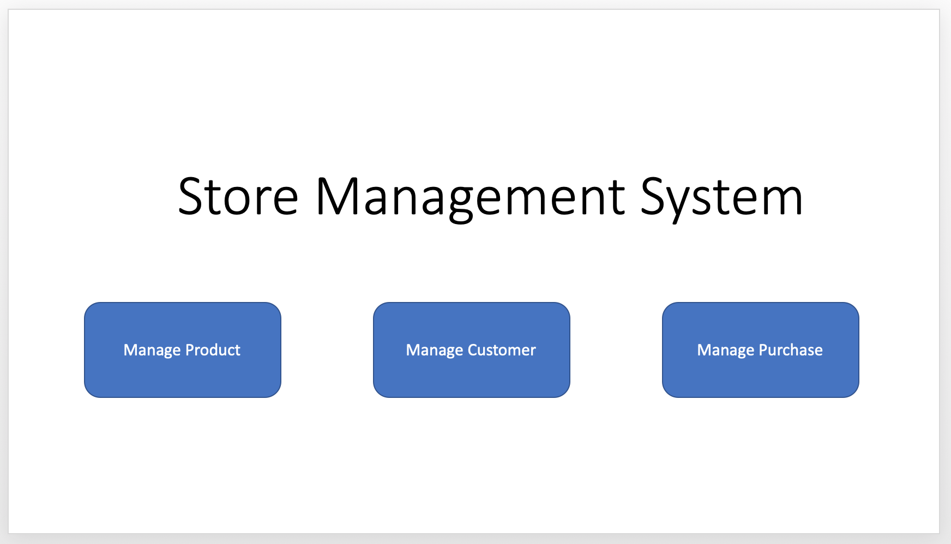

Manage Product

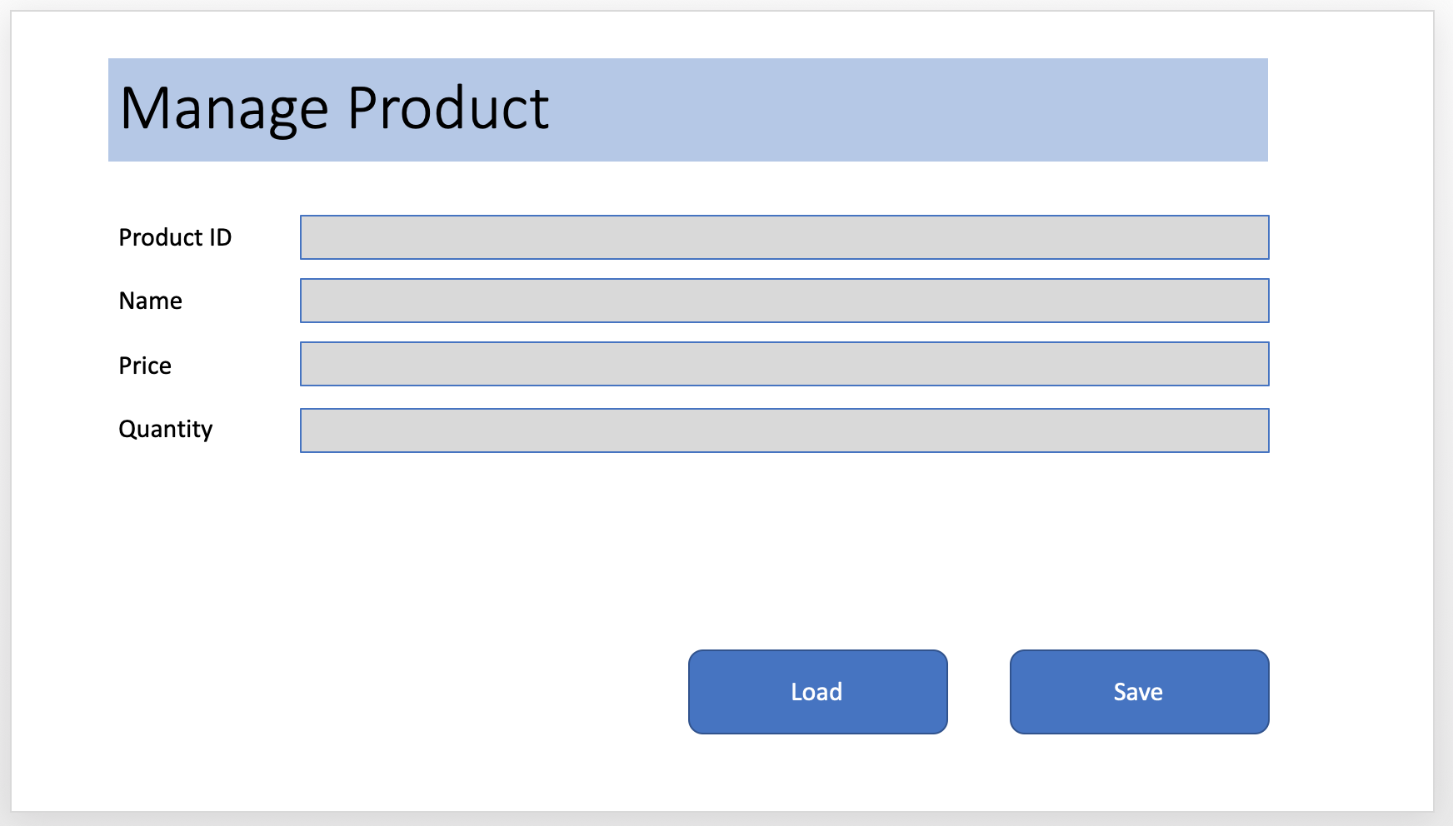

Product Saved

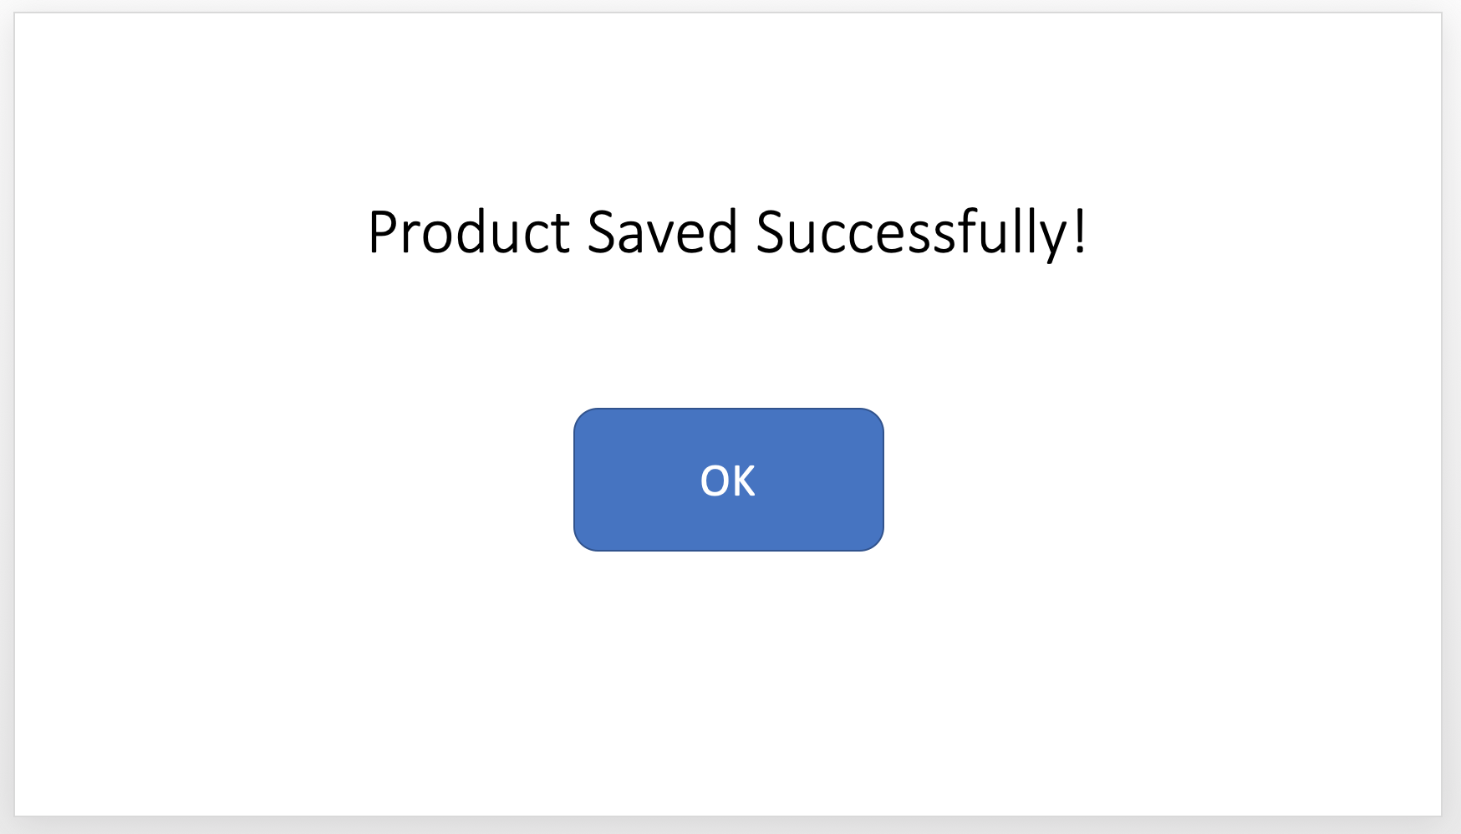

Manage Customer

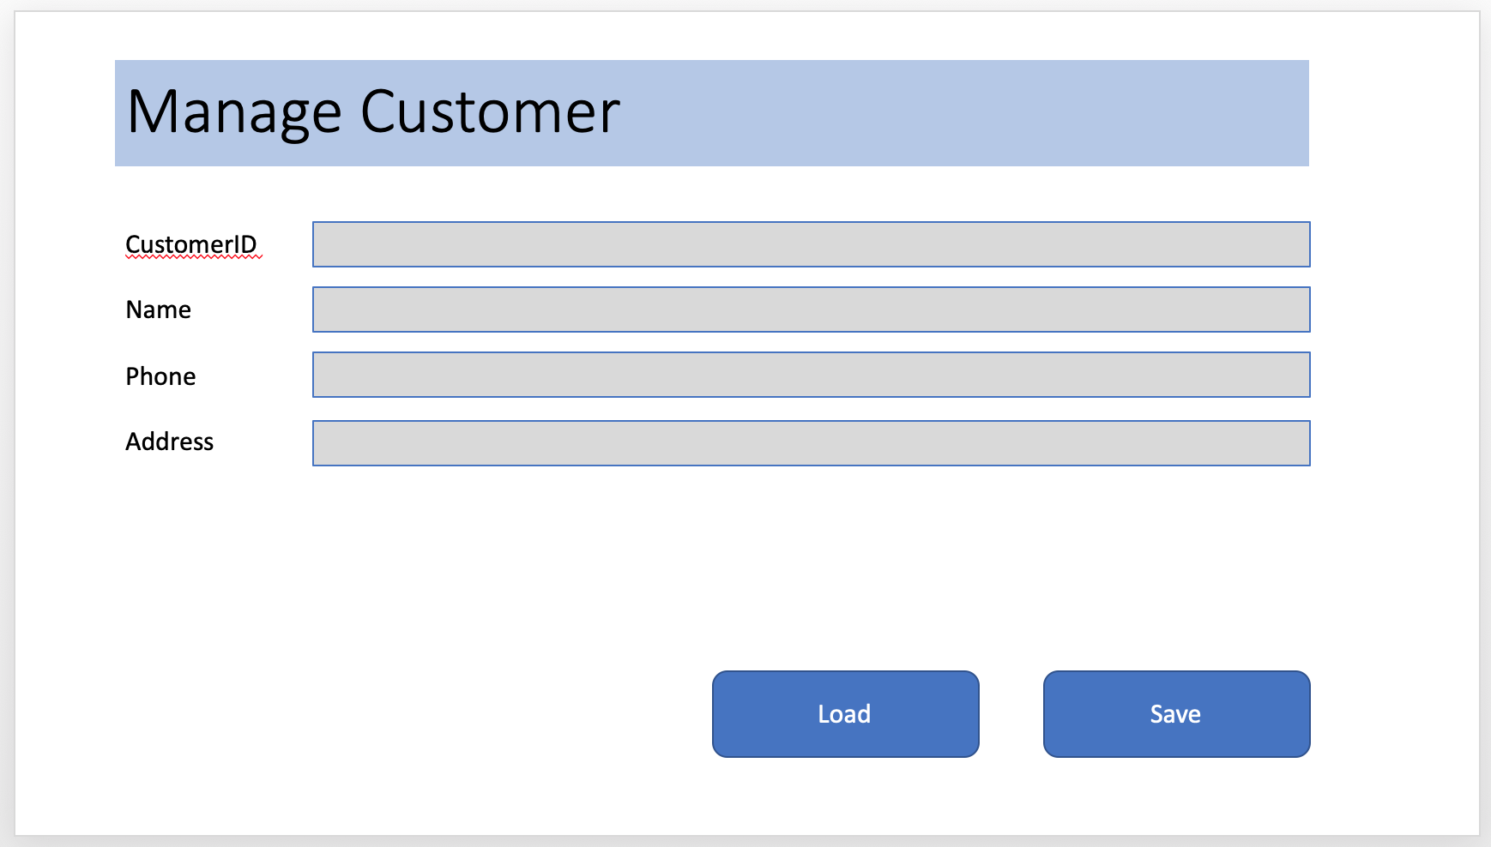

Customer Saved

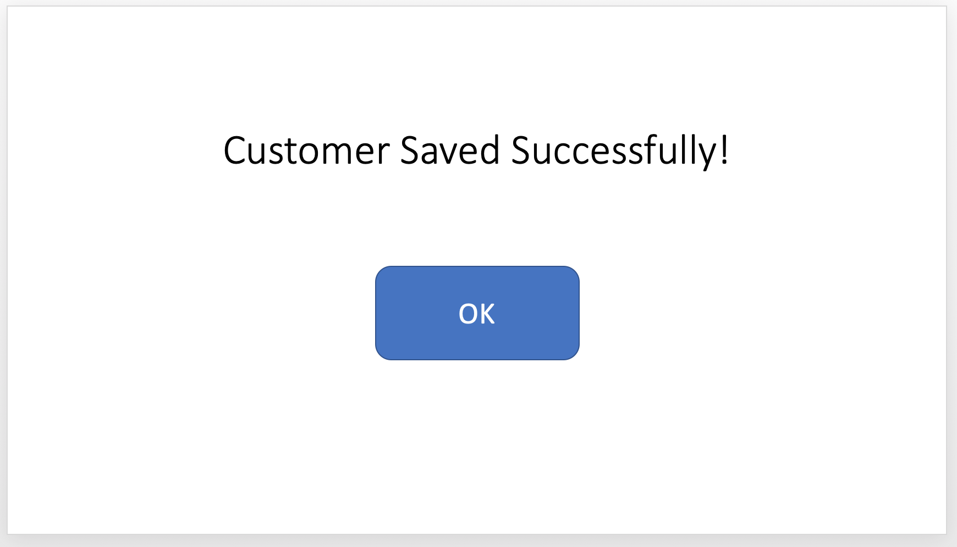

Manage Purchase

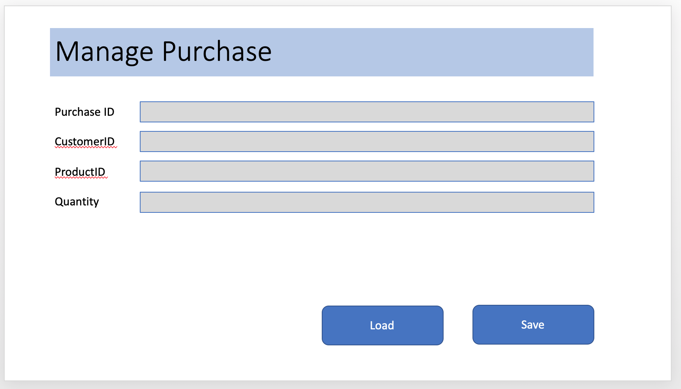

Purchase Saved

